Docker

Steps to run a python application –

1. App.py(helloworld.py)
2. Dockerfile

Commands

Docker

mkdir shelldocker

cd shelldocker/

sudo su

docker build -t shellida-python-app .

docker run shellida-python-app

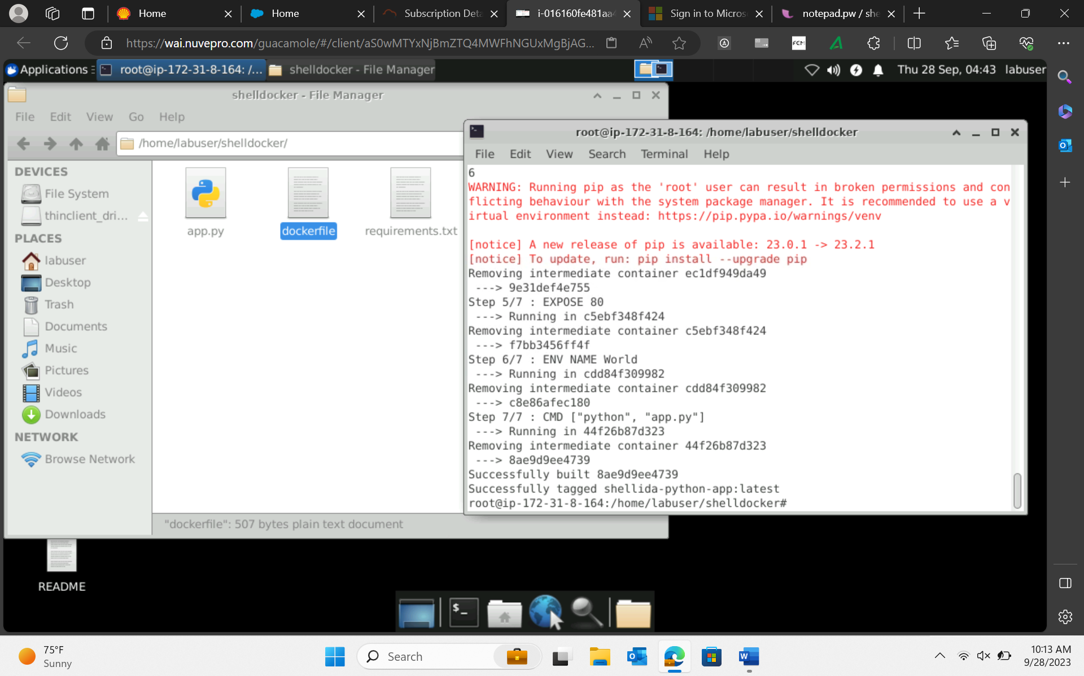

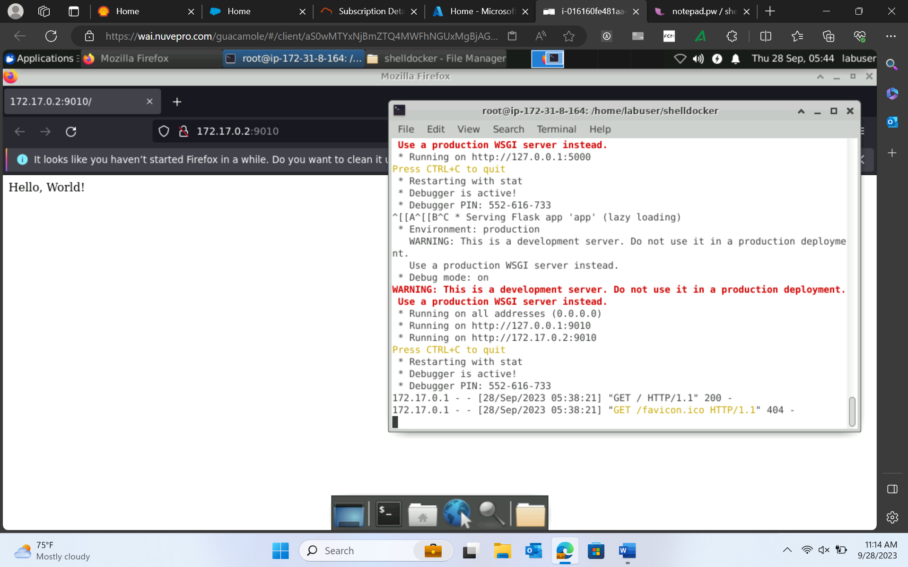

Link docker image to azure

Need azure cli – new terminal

#to install azure-cli

curl -sL https://aka.ms/InstallAzureCLIDeb | sudo bash

#to check the azure cli

az

#to login azure account

az login -u username -p

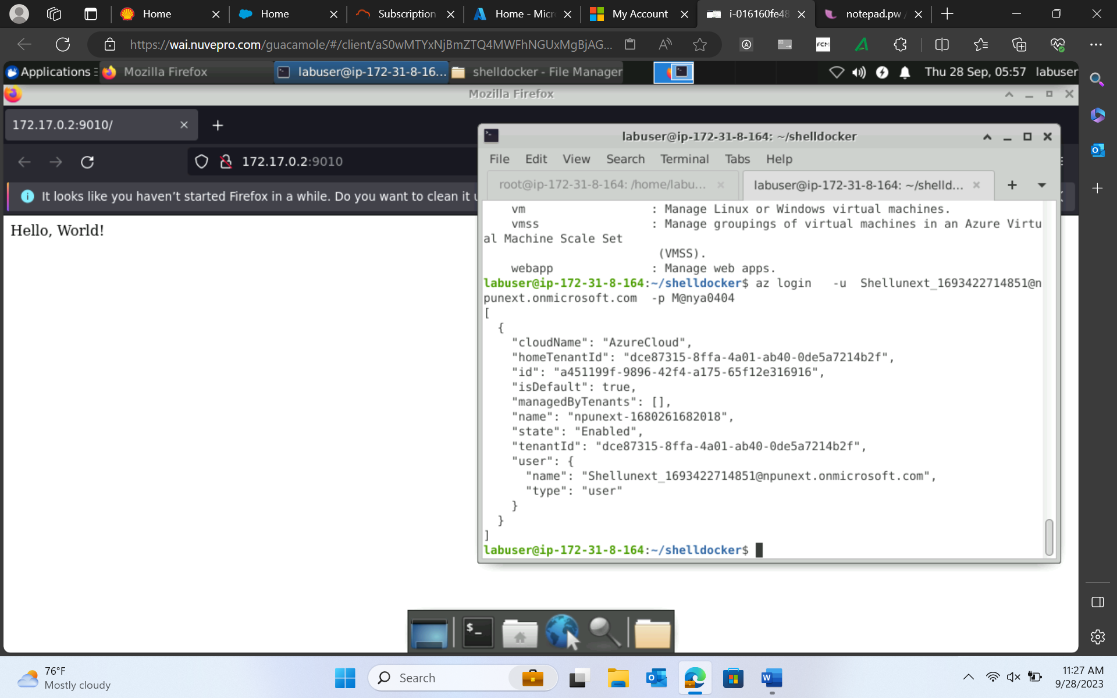

All the azure services can now be handled from here.

Create azure Container Registry

az acr login --name acrcontainername

docker tag shellida-python-app shellidaacrpy.azurecr.io/ida-python-app:v1

docker push shellidaacrpy.azurecr.io/ida-python-app:v1

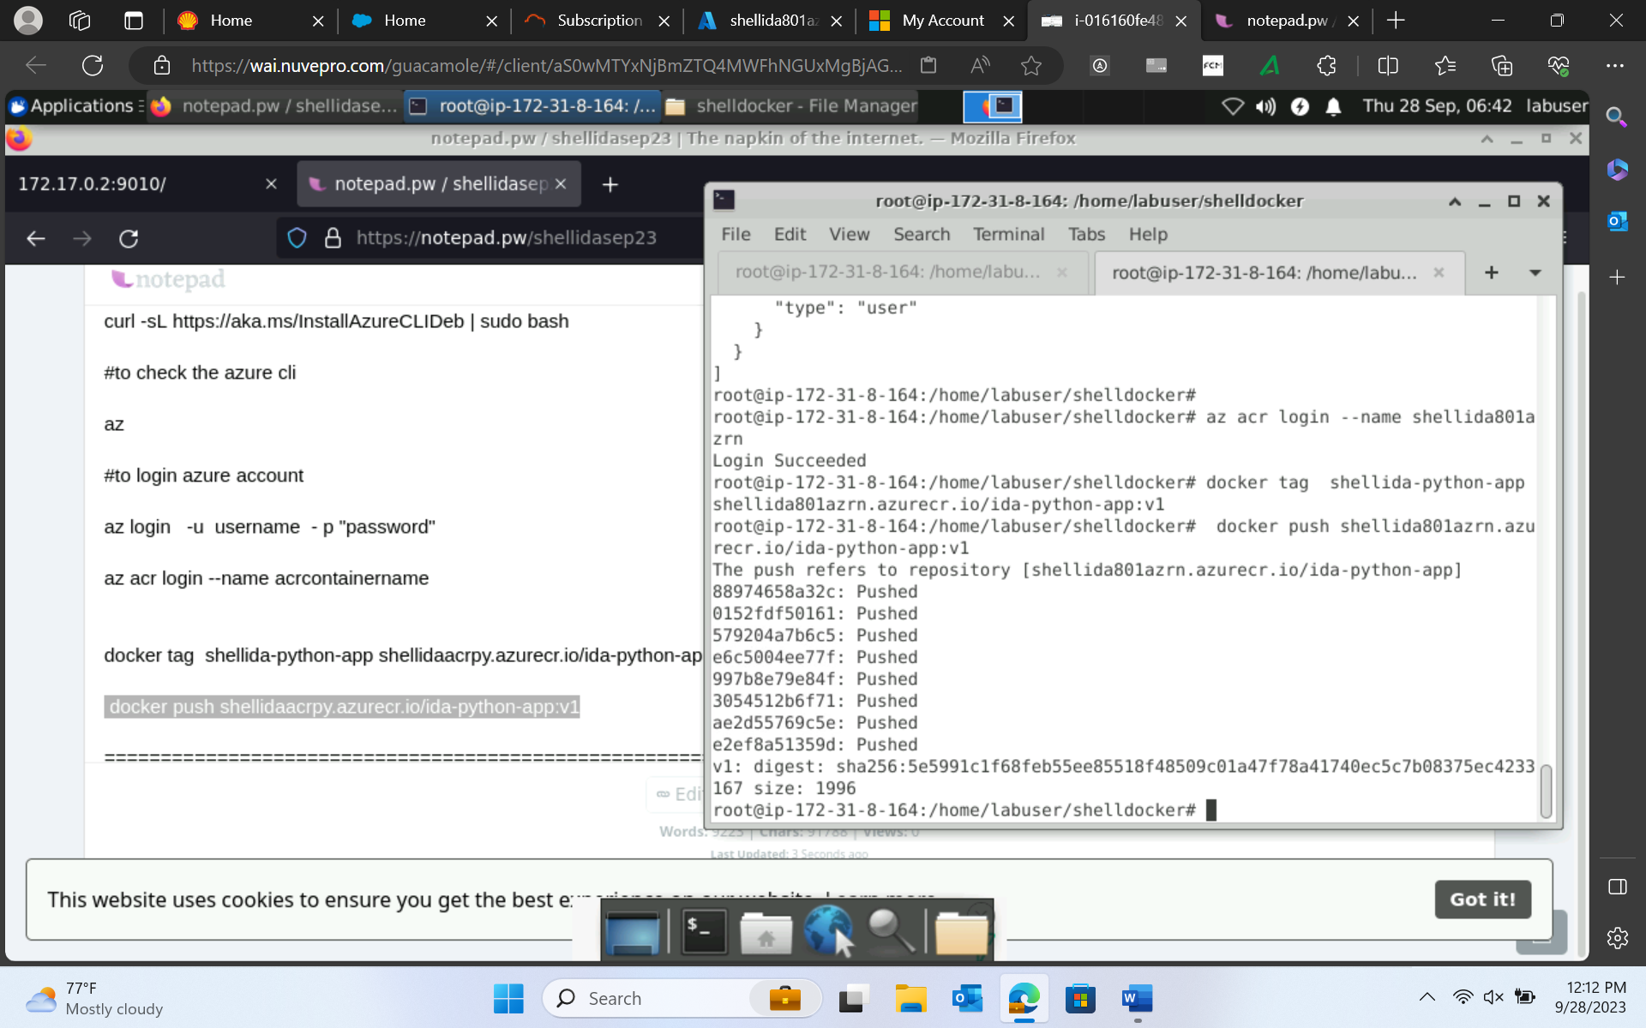

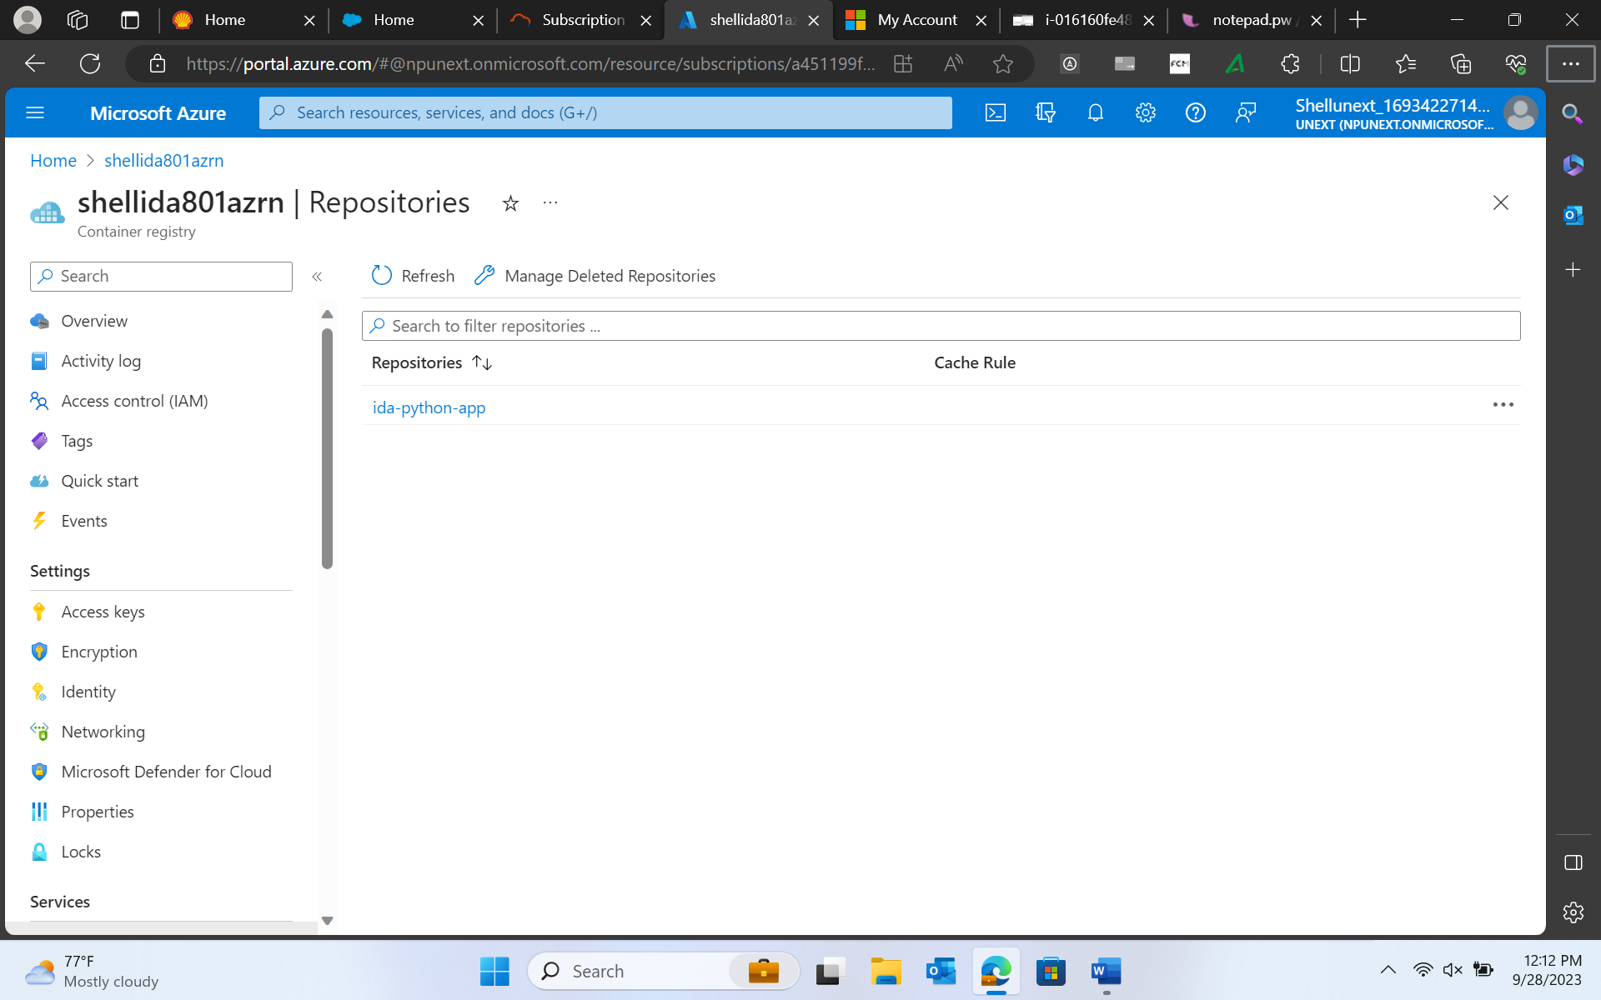

Now to deploy we need cluster 🡪 Kubernetes 🡪 Kubernetes services 🡪 new cluster

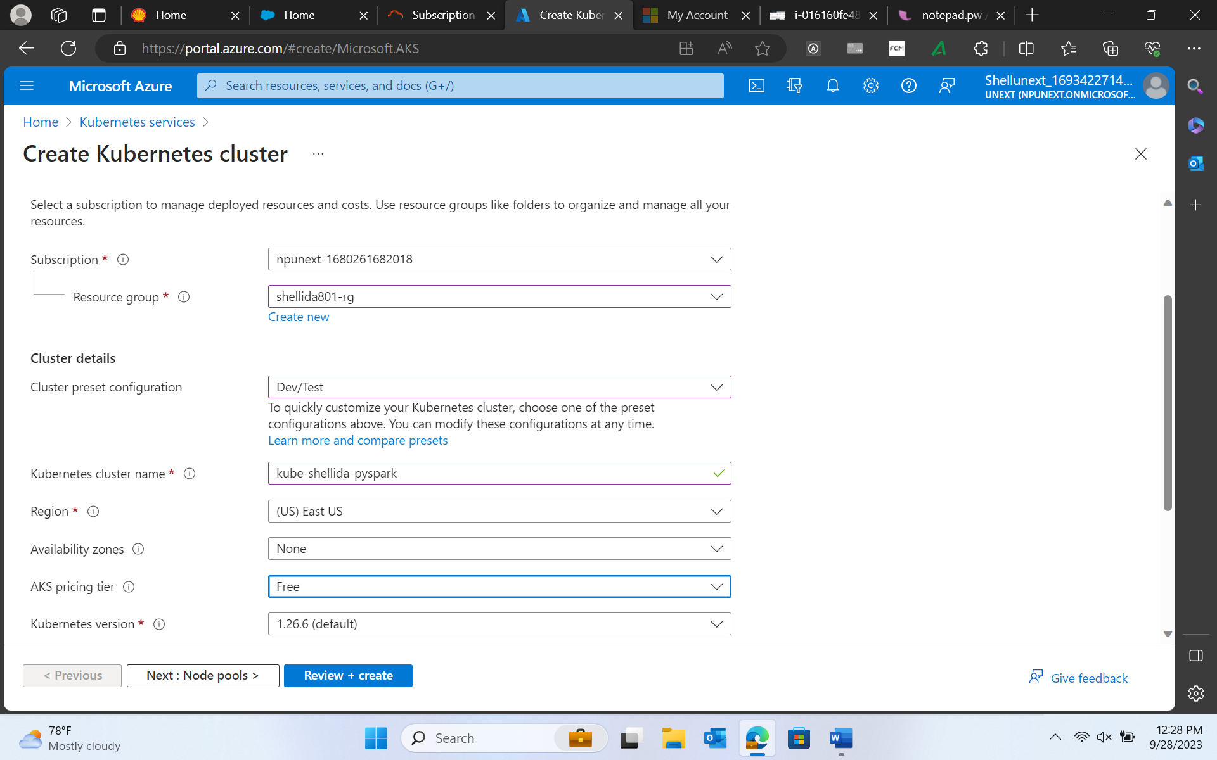

In node pool change node count bcoz we don’t have a big application to run.

